**Chapter 1**

1.1 Introduction1

1.2 Site Map 2

1.3 Design 3

1.4 Implementation 4

1.5 Conclusion5

1.6 Appendix 6

**1.1 Introduction**

The SCAWS website was developed to serve as a comprehensive online platform for STANLEY COMPANY AND WORK SERVICES (SCAWS), showcasing its wide range of services including residential, commercial, and industrial painting, cleaning, decoration, wall and ceiling design, skimming, and wallpaper installation. The website’s main purpose is to attract clients, provide detailed information about the company’s offerings, and facilitate seamless communication with prospective customers. With the growing trend of businesses transitioning to online platforms, SCAWS recognized the need for a professional and user-friendly website to enhance visibility, improve customer interaction, and streamline service requests.

**Purpose**: The website acts as a centralized hub for clients seeking information about SCAWS services. It serves to educate, inform, and engage users, thus increasing client conversion rates and maintaining a professional online presence. The website is designed not only to attract new customers but also to provide ongoing support and information to existing clients.

**Target Audience**: The primary audience for the SCAWS website includes homeowners, property managers, and businesses looking for quality painting, cleaning, and decoration services. These users are typically looking for reliability, affordability, and professionalism. The site is designed to cater to both tech-savvy users who expect an interactive online experience and those less familiar with technology who may need more straightforward navigation and information.

**Objective**: The primary objective of the SCAWS website is to provide easy access to detailed service descriptions and facilitate client inquiries. This includes enabling online bookings, inquiries through contact forms, and access to customer testimonials. The website aims to improve business efficiency by offering customers an alternative communication channel and promoting services through a visually appealing gallery of completed projects.

**1.2 Site Map**

This site map is textual representation of the website’s structure, making it easier for users to understand the flow and navigate the site effectively.

**Homepage**

Path: /html/homepage.html

Description: This page serves as the main entry point for the SCAWS website. It provides a welcoming introduction to the services offered by Stanley Company And Works Services (SCAWS). The layout includes a navigation bar at the top, which allows users to easily navigate to other sections of the site (Services, Gallery, About, Contact Us). The homepage features a brief welcome message highlighting SCAWS’ wide range of services and specialties, including residential, commercial, and industrial painting, cleaning services, and home/office decoration.

Navigation Bar

Location: Top of the homepage

Description: The navigation bar includes links to the main sections of the website: Home, Services, Gallery, About, and Contact Us. It is designed to be easily accessible and user-friendly, with dropdown menus or secondary pages for more detailed service descriptions. The bar also features a burger icon for mobile responsiveness, which opens and closes a dropdown menu with the same links when clicked.

Welcome Message

Location: Centered on the homepage

Description: The welcome section introduces visitors to SCAWS, outlining the company’s expertise and range of services. It includes:

Heading: A welcoming message with a heading as shown on **figure 1.1 (**WELCOME TO STANLEY COMPANY AND WORK SERVICES.) to catch the visitor's attention.

About Section: A detailed paragraph that explains what SCAWS does, including residential, public, commercial, and industrial painting; cleaning services (indoors and outdoors); home and office decoration; wall and ceiling design; skimming; and wallpaper installation. This section emphasizes transformation and satisfaction in service delivery.

Pictures Grid

Location: Below the welcome message, arranged in a 3x1 grid

Description: The picture grid showcases recent completed projects by SCAWS. Each image is displayed in a square format, with each project represented by a different photo. The images provide visual evidence of the quality and variety of work SCAWS offers. The grid consists of:

First Image: A completed painting project.

Second Image: Another completed painting project, potentially with a different color palette or style.

Third Image: A final completed project, showing a different service such as wallpaper installation or ceiling design.

Footer

Location: Bottom of the homepage

Description: The footer provides additional contact information and links to connect with SCAWS:

Get In Touch: A heading inviting visitors to reach out to SCAWS.

Contact Information: Includes a direct email link (kongwiepercy9@gmail.com), a telephone number (0550710451), and icons linking to social media platforms (Facebook, WhatsApp, Instagram). These links allow visitors to easily contact the company or follow updates on social media.

Social Media Icons: Three icons representing different social media platforms (Facebook, Instagram, WhatsApp) for quick access to SCAWS’ online presence.

Copyright Statement: A note about copyright and site security (© 2024 by Stanley Company And Works Services. Powered and secured by).

JavaScript for Navigation

Script: /Script/navBar.js

Description: The script is used to make the navigation bar responsive, particularly for mobile devices. It handles the opening and closing of the navigation menu when the burger icon is clicked, ensuring a seamless experience for users navigating the site on different devices.

Fig 1.1 Homepage

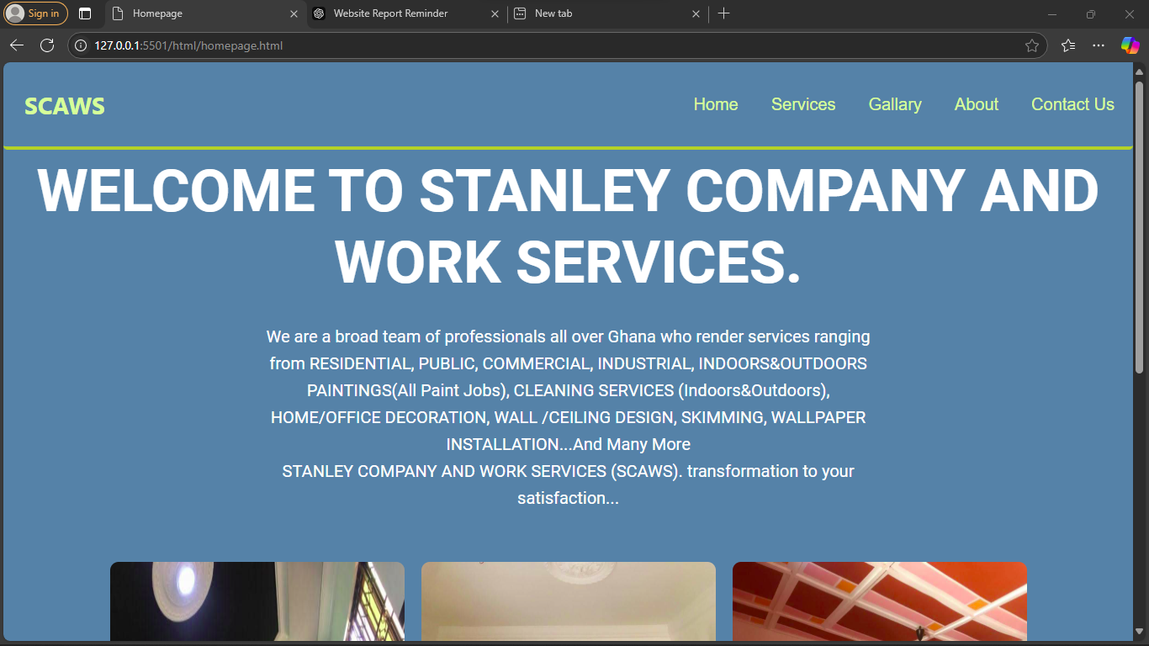

**Services Page**

Path: /html/Services.html

Description: This page provides detailed information about the various services offered by SCAWS:

Introduction: A heading as shown on **figure 1.2** (Our Services) and introductory paragraph that explains the breadth of services provided by SCAWS, from residential and commercial painting to detailed cleaning, decor, and wall design. It emphasizes SCAWS' capability to handle projects of all scales and styles across Ghana.

Service Categories:

Residential & Commercial Painting:

Image: Image of completed painting projects

Description: An overview of the painting services provided by SCAWS, Including vibrant interiors and weatherproof exteriors.

Cleaning Services (Indoors & Outdoors):

Image: Image of a cleaning service in action

Description: Details about professional cleaning services for homes, offices, and public spaces, focusing on thorough, high-quality cleaning.

Home & Office Decoration:

Image: Image showcasing decorated spaces

Description: Information about the decoration services offered, highlighting custom designs and the collaboration process with clients.

Wall & Ceiling Design:

Image: Image of custom wall and ceiling designs

Description: Explanation of custom design capabilities, including creative textures and patterns for walls and ceilings.

Skimming & Surface Preparation:

Image: Image of skimming process

Description: Details about skimming services, emphasizing the importance of a smooth surface for painting and wallpaper installation.

Wallpaper Installation:

Image: Image of wallpaper installation

Description: Information about different wallpaper patterns and textures, and the installation process to ensure a perfect fit.

Navigation Bar

Location: Top of the Services page

Description: The navigation bar includes links to the main sections of the website: Home, Services, Gallery, About, and Contact Us. It is designed to be easily accessible and user-friendly, with dropdown menus or secondary pages for more detailed service descriptions. The bar also features a burger icon for mobile responsiveness, which opens and closes a dropdown menu with the same links when clicked.

Footer

Location: Bottom of the Services page

Description: The footer provides additional contact information and links to connect with SCAWS:

Get In Touch: A heading inviting visitors to reach out to SCAWS.

Contact Information: Includes a direct email link (kongwiepercy9@gmail.com), a telephone number (0550710451), and icons linking to social media platforms (Facebook, WhatsApp, Instagram). These links allow visitors to easily contact the company or follow updates on social media.

Social Media Icons: Three icons representing different social media platforms (Facebook, Instagram, WhatsApp) for quick access to SCAWS’ online presence.

Copyright Statement: A note about copyright and site security (© 2024 by Stanley Company And Works Services. Powered and secured by).

JavaScript for Navigation

Script: /Script/navBar.js

Description: The script is used to make the navigation bar responsive, particularly for mobile devices. It handles the opening and closing of the navigation menu when the burger icon is clicked, ensuring a seamless experience for users navigating the site on different devices.

Fig 1.2 Services Page

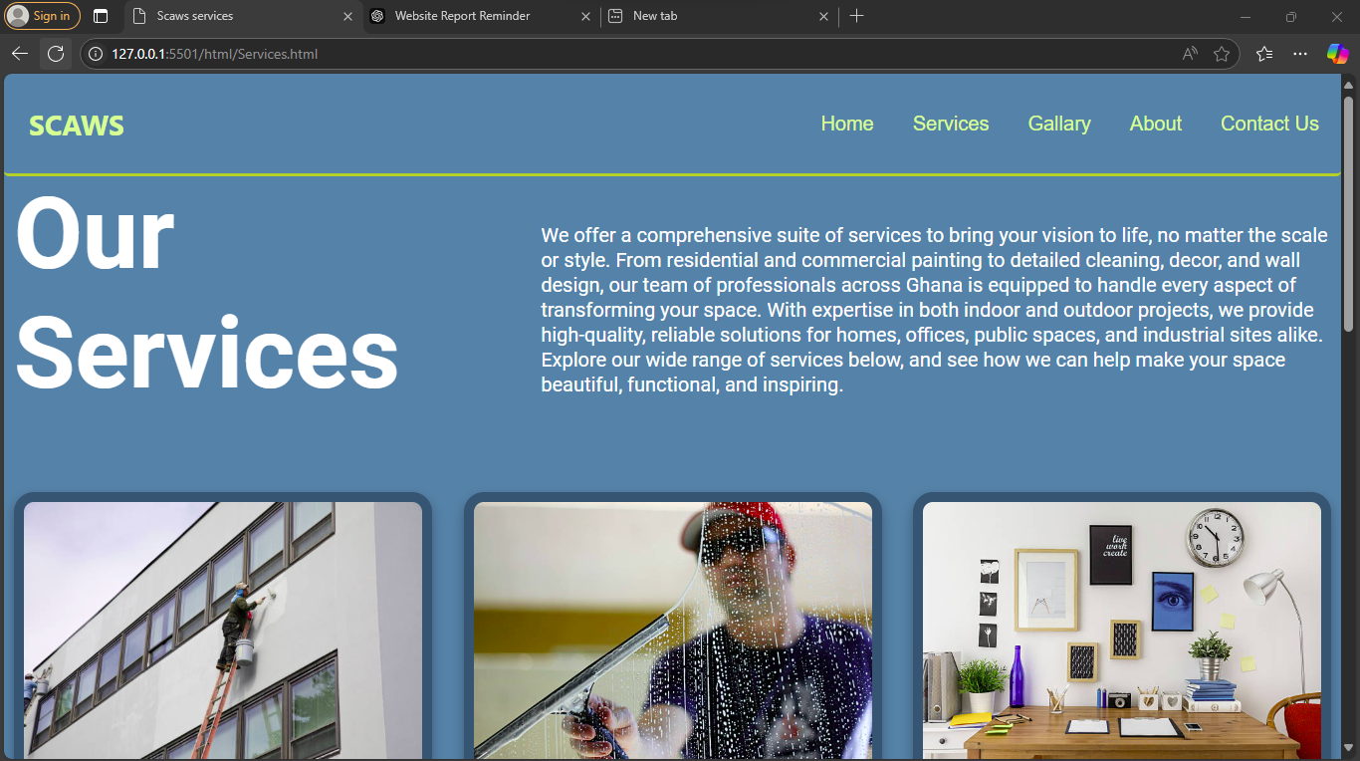

**Gallery Page**

Path: /html/Gallary.html

Description: This page showcases a collection of completed projects by SCAWS:

Completed Projects Header:

Heading: Completed Projects

Location: Top of the page, setting the theme for the gallery.

Project Images shown on **figure 1.3** :

Image Row 1:

Images:

/images/Completed projects/IMG01-20241207-WA0004.jpg

/images/Completed projects/IMG02-20241207-WA0006.jpg

Description: This row displays the first set of completed projects images, providing visual evidence of SCAWS’ work in painting, decoration, and more.

Image Row 2:

Images:

/images/Completed projects/IMG3-20241207-WA0005.jpg

/images/Completed projects/IMG04-20241207-WA0008.jpg

Description: A second row of project images showcasing different work types and styles.

Image Row 3:

Images:

/images/Completed projects/IMG05-20241207-WA0007.jpg

/images/Completed projects/IMG06-20241207-WA0003.jpg

Description: The final row of images further demonstrates the variety and quality of completed projects, from painting to decoration.

Navigation Bar

Location: Top of the Gallery page

Description: The navigation bar includes links to the main sections of the website: Home, Services, Gallery, About, and Contact Us. It is designed to be easily accessible and user-friendly, with dropdown menus or secondary pages for more detailed service descriptions. The bar also features a burger icon for mobile responsiveness, which opens and closes a dropdown menu with the same links when clicked.

Gallery Layout

Location: Centered in the page

Description: The gallery is divided into rows of images to provide a visual representation of completed projects:

Three Rows of Project Images:

Row 1: Displays two images side by side, showing different project examples.

Row 2: Contains another two images, demonstrating the variety of work completed by SCAWS.

Row 3: The final set of images to showcase the latest or most representative projects, allowing users to scroll through and view different angles and perspectives.

Footer

Location: Bottom of the Gallery page

Description: The footer provides additional contact information and links to connect with SCAWS:

Get In Touch: A heading inviting visitors to reach out to SCAWS.

Contact Information: Includes a direct email link (kongwiepercy9@gmail.com), a telephone number (0550710451), and icons linking to social media platforms (Facebook, WhatsApp, Instagram). These links allow visitors to easily contact the company or follow updates on social media.

Social Media Icons: Three icons representing different social media platforms (Facebook, Instagram, WhatsApp) for quick access to SCAWS’ online presence.

Copyright Statement: A note about copyright and site security (© 2024 by Stanley Company And Works Services. Powered and secured by).

JavaScript for Navigation

Script: /Script/navBar.js

Description: The script is used to make the navigation bar responsive, particularly for mobile devices. It handles the opening and closing of the navigation menu when the burger icon is clicked, ensuring a seamless experience for users navigating the site on different devices.

Fig 1.3 Gallery Page Showing some completed works

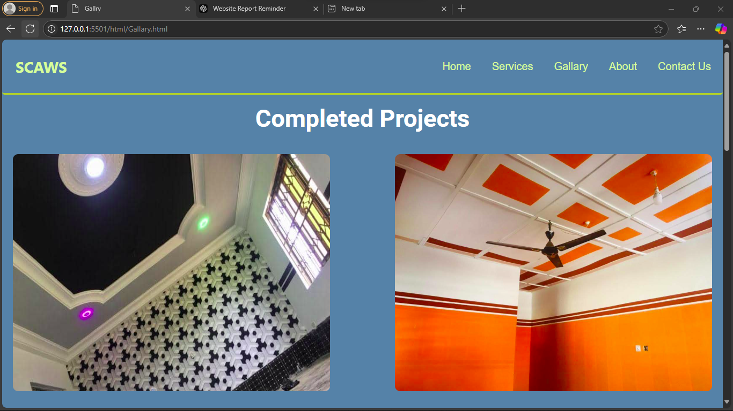

**About Page**

Header:

Location: The header is positioned at the top of the page, ensuring that it is the first element users see when accessing the page.

Description: The header prominently features the company’s name, “SCAWS,” in bold. It also includes a navigation menu with links to the main sections of the website: Home, Services, Gallery, About, and Contact Us. This layout helps maintain consistency across the website and makes it easy for users to navigate.

Burger Icon: The inclusion of a burger icon within the navigation bar provides an interactive element for mobile users. When clicked, this icon reveals a dropdown menu with the same links, ensuring a responsive design for better user experience across devices.

About Us Section Shown on **figure 1.4**:

Location: This section is centered on the page, allowing users to easily locate and read the content.

Heading: "About Stanley Company and Work Services (SCAWS)"

Subheading: "Transformation to Your Satisfaction"

Description: The section begins with a clear and concise introduction to SCAWS, describing the company as a team of skilled professionals based across Ghana, dedicated to delivering exceptional service. This sets the tone for what visitors can expect from SCAWS and builds credibility with potential clients.

Who We Are:

Content: A detailed description of SCAWS, highlighting its expertise in painting, cleaning, and decoration services. It emphasizes the company’s commitment to quality and customer satisfaction, outlining the diversity of services provided.

Impact: This section effectively conveys the company’s mission and values, helping visitors understand the scope of work and the quality standards SCAWS adheres to.

Mission Section:

Location: Positioned below the "Who We Are" section.

Heading: "Our Mission"

Content: The mission statement is clear and direct, emphasizing SCAWS’ goal to provide reliable, high-quality services that exceed client expectations. It reinforces the company’s dedication to customer satisfaction and high standards of service delivery.

Services Section:

Location: This section follows the mission statement and is presented in a visually appealing format with a centered layout.

Heading: "Our Services"

Content: The services offered by SCAWS are listed with detailed descriptions, including:

Painting Services: Comprehensive painting solutions for all types of spaces, both residential and commercial.

Home and Office Decoration: Tailored decoration solutions to enhance spaces’ style and functionality.

Cleaning Services: Professional cleaning for both indoor and outdoor environments.

Wall and Ceiling Design: Creative and innovative designs to add personality to interiors.

Skimming & Wallpaper Installation: High-quality finishes with wall skimming and wallpaper installation.

Impact: This section effectively communicates the range of services provided by SCAWS, allowing potential clients to see the breadth of expertise available. Each service is explained clearly, reinforcing the company’s capabilities.

Why Choose SCAWS Section:

Location: Positioned below the services section, this section is also centered.

Heading: "Why Choose SCAWS?"

Content: This section outlines the key reasons to choose SCAWS, including years of experience, a dedicated team, and a client-centered approach. It provides a compelling narrative about the benefits of working with SCAWS, such as personalized service and the ability to transform spaces to meet client needs.

Impact: It helps build confidence in potential clients by addressing common concerns and demonstrating why SCAWS stands out among competitors.

Footer:

Location: The footer is placed at the bottom of the page, providing additional information and contact options.

Description: The footer includes a “Get In Touch” heading, direct contact information (email and phone number), and links to social media platforms (Facebook, WhatsApp, Instagram). This allows visitors to easily reach out to SCAWS or follow updates on social media.

Social Media Icons: The icons provide quick access to SCAWS’ online presence, facilitating communication and engagement with the company.

Copyright Statement: The footer includes a copyright statement (© 2024 by Stanley Company And Works Services. Powered and secured by SCAWS). This helps reassure visitors of the company’s commitment to professionalism and security.

JavaScript for Navigation:

Script: /Script/navBar.js

Description: The script enables the responsive functionality of the navigation bar, particularly for mobile users. It handles the opening and closing of the navigation menu when the burger icon is clicked, ensuring a seamless user experience across devices.

Fig 1. 4 About page showing Who we are and our Mission

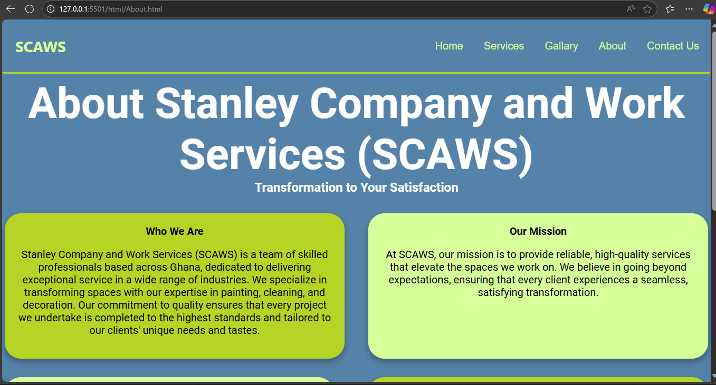

**Contact Us Page**

Header:

Location: The header is positioned at the top of the page, providing immediate visibility and access to the main sections of the website.

Description: It includes the company’s name “SCAWS” prominently. The navigation menu within the header includes links to other sections of the site: Home, Services, Gallery, About, and Contact Us. This design element ensures users can navigate easily through the site.

Burger Icon: The inclusion of a burger icon is a key feature for mobile responsiveness. It allows users to open and close a dropdown menu, ensuring a seamless experience on different devices.

Contact Us Heading:

Location: Positioned as the main heading at the top of the page, centered for visibility.

Heading: "Contact Us for a Service"

Content: This clear and direct heading establishes the purpose of the page and encourages visitors to get in touch. It sets the stage for the sections that follow and helps to focus visitor attention on the next steps.

Contact Form Shown on **figure 1.5**:

Location: The form is placed in the center of the page, allowing easy access for users.

Description: The form is well-structured with different sections for user information, making it user-friendly and straightforward:

First Name and Last Name fields: Required inputs to personalize the communication.

Email and Telephone fields: Essential for contacting the user.

City field: Optional input that can help SCAWS understand the geographic distribution of its clients.

Service Selection: A dropdown menu that allows users to choose from different services offered by SCAWS, providing context to the inquiry.

Submit Button: The button includes a JavaScript onclick event that triggers an alert message to confirm the submission of details. This feature helps reassure users that their information has been sent.

Footer:

Location: Positioned at the bottom of the page, providing additional contact details and a way for users to reach out.

Description: The footer includes:

Get In Touch Heading: Emphasizes the importance of contact.

Contact Information: Direct email link (kongwiepercy9@gmail.com) and telephone number (0550710451) to facilitate communication.

Social Media Icons: Links to various platforms (Facebook, WhatsApp, Instagram) are provided for further engagement. These icons enable users to connect with SCAWS on social media, which can help build a community and maintain ongoing communication.

Copyright Statement: Includes a copyright note (© 2024 by Stanley Company And Works Services. Powered and secured by SCAWS). This reassures visitors about the security and professionalism of the website.

JavaScript Functionality:

Script: /Script/navBar.js

Description: The JavaScript script ensures the navigation bar is responsive, particularly on mobile devices. It manages the opening and closing of the navigation menu when the burger icon is clicked. This functionality enhances the user experience by making it easier to navigate the site on mobile devices, thus improving accessibility and usability.

Fig 1.5 Showing Contact us form

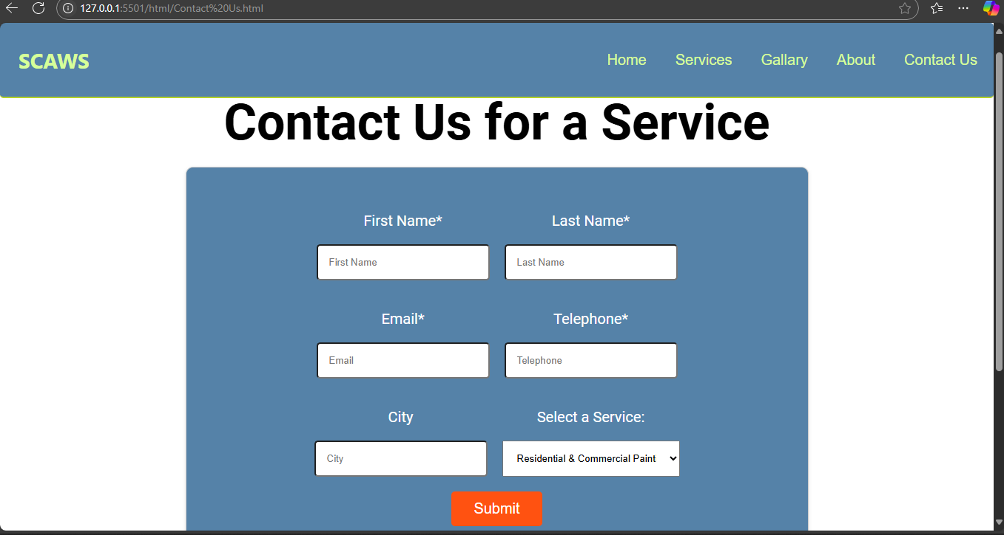

**1.3. Design**

The design of the SCAWS website was carefully considered to ensure it was user-friendly, visually appealing, and aligned with the company’s brand identity.

Design Choices:

Color Scheme: The color palette was chosen to create a warm, welcoming feel, reflecting the company’s emphasis on customer service and quality. Soft blues and greens were used to evoke feelings of trust and calm, which are ideal for service-based industries where professionalism and reliability are key. Accents of orange were used to draw attention to important elements such as contact buttons and promotional messages.

Typography: The typography was selected for readability and style, ensuring that all text was easily legible across devices. A combination of Roboto sans-serif fonts was used for body text to enhance readability, while serif fonts were reserved for headlines to add a sense of sophistication. Font sizes were adjusted for different devices to ensure a consistent reading experience across mobile, tablet, and desktop platforms.

Responsive Design: The website was built with a mobile-first approach, utilizing media queries to adjust layouts for tablets and desktops. The use of fluid grids and flexible images allowed the content to adapt to different screen sizes, enhancing user experience on mobile devices. Code snippets for and snapshot of pages and media queries are provided in the appendix to demonstrate the responsive design implementation.

**1.4. Implementation**

The development of the SCAWS website involved multiple steps from planning to deployment. This section provides a detailed explanation of each phase, focusing on the technologies used and challenges faced.

Technologies Used:

HTML: The HTML was structured to be semantic, using sections and article tags to make the content more accessible. Example code snippets are provided in the appendix for specific elements, such as the header, navigation bar, and contact form structure.

CSS: Stylesheets were used to manage the layout, with modular files for different sections (e.g., home.css, services.css). This approach helped keep the code organized and maintainable. Examples of CSS for responsive design (media queries) are provided to illustrate how different breakpoints were handled.

JavaScript: The site uses JavaScript for interactivity, particularly for the navigation bar (navBar.js). This script handles the dropdown menus and links between sections. A snippet of this code is included in the appendix to show how the navigation bar was implemented.

PHP (PHPMailer): PHPMailer was integrated to handle email submissions from the contact form securely. This solution was chosen to avoid using third-party services and keep communication within the site’s domain. Example PHP code for handling form submissions is included in the appendix.

Development Process:

Planning and Requirements Gathering: Collaborated with stakeholders to understand their needs and the target audience.

**1.5. Conclusion**

The SCAWS website was successfully developed to meet its objectives of enhancing customer engagement and providing a professional online presence for STANLEY COMPANY AND WORK SERVICES. Through careful planning, design, and implementation, the site effectively showcases SCAWS services, supports business operations, and facilitates client communication.

Summary: The website serves as a comprehensive online portfolio, allowing customers to easily browse services, view completed projects, and contact the company for inquiries. By offering detailed information about each service and integrating client testimonials, the site builds trust and confidence in potential customers.

Future Enhancements:

E-commerce Integration: Potential future development could include an e-commerce section for booking services and purchasing materials directly online.

Advanced SEO Strategies: Enhancing search engine optimization through structured data and content optimization could improve visibility in search engine results.

User Feedback Mechanisms: Adding a feedback form or survey could provide insights into user experience and satisfaction, allowing for continuous improvement.

**1.6. Appendix**

Mobile View of Some Pages

Fig 1. 6 Homepage

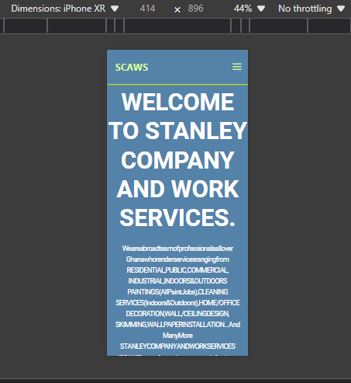

Fig 1.7 Gallery Page

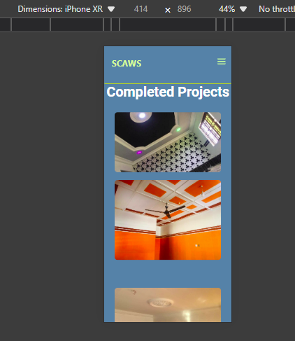

Fig 1.8 Contact Us page

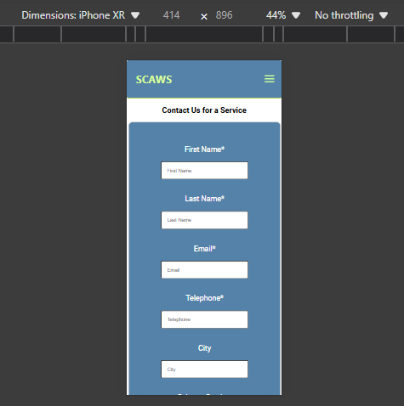

Code Snippets:

JavaScript For Responsiv Navigation bar

document.querySelector('.burger').addEventListener('click', () => {

const nav = document.querySelector('.header-right');

nav.classList.toggle('active');

});

CSS

Fig 1.9 Responsive layout using media queries:

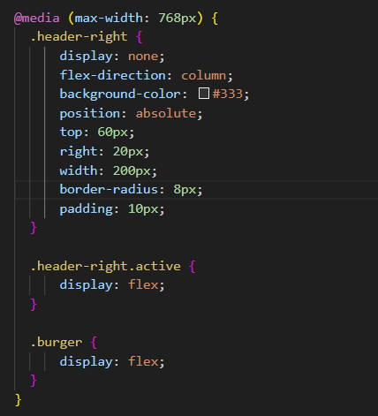

PHP:

Fig 1.10 Contact form handling with PHPMailer

